Department of commercial activity

Manual

Capacity booking by Customers in the SSO`s I-platform

Version 1.3
17.09.2020
Consultations:

e-mail: | Iplatforma-psg@utg.ua
Contact phone: | (044) 298-81-51

Logging in

To log in to IPlatforma of SSO, use the link in your web browser (Google Chrome is preferable):
https://iplatforma-ogu.utg.ua/start_en
The window of web browser shall open:

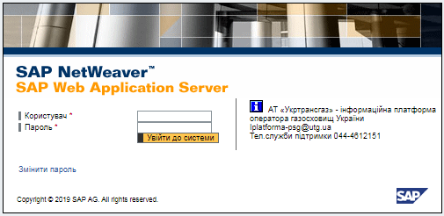
You need to access to your personal account.
To do this, fill in the following fields in the window:
User - insert your login (I-platform SSO user account);
Password - initial password is used at first login.
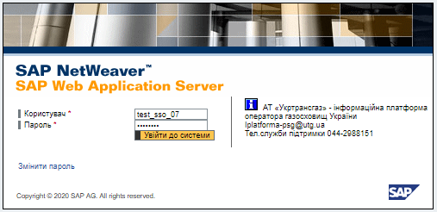

Attention! The password, provided you by e-mail, has to be changed within 3 days.

Capacity booking

The process of filling the capacity bookings by customers of storage services in the I- platform of the SSO is performed using the menu item "Capacity Booking". To access, just double-click on the selected line.
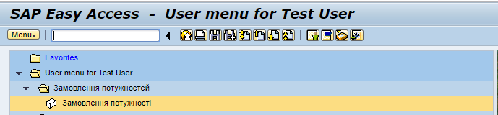
On the first screen of the capacity booking transaction, an area for entering the date is available:
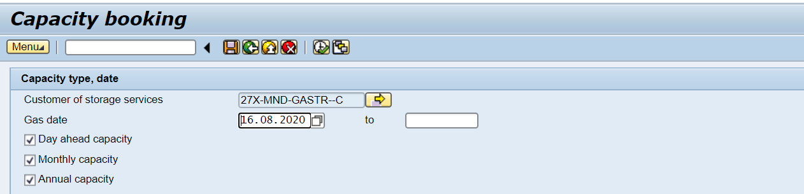
The Customer`s EIC code is filled in automatically according to your account.
The current date is filled in automatically. It is possible to enter the required date by yourself or use the calendar:
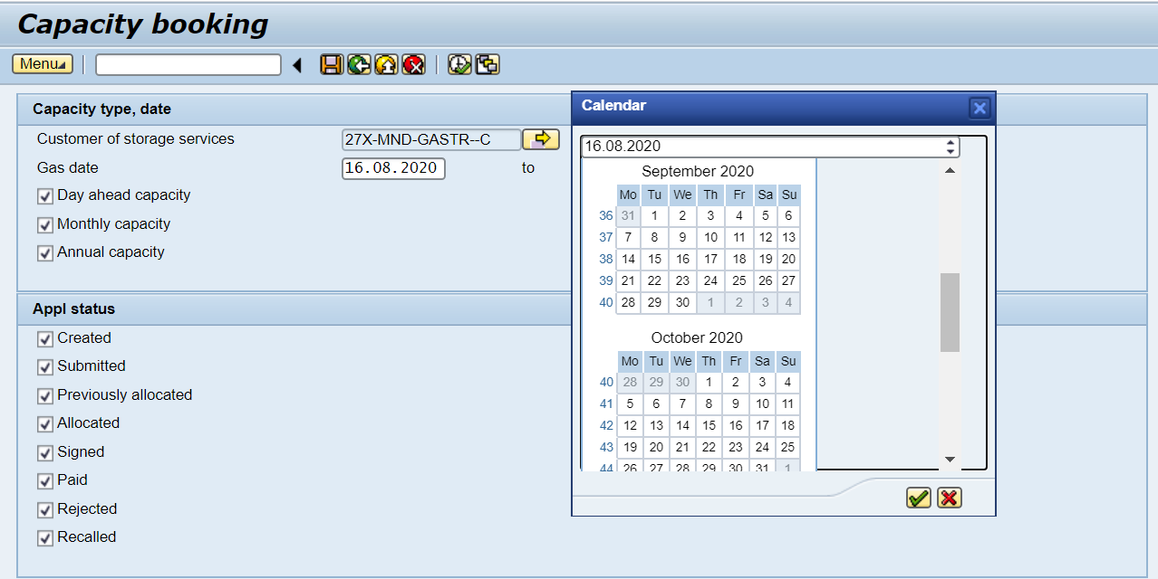
It is possible to view requests for capacity orders for a specific period of time:
- daily capacity;
- monthly capacity;
- annual capacity.
To do this, put a "tick" in front of the selected capacity type:

Creating an application:

To create a request for capacity booking by Customer of storage services, you must click "Execute":
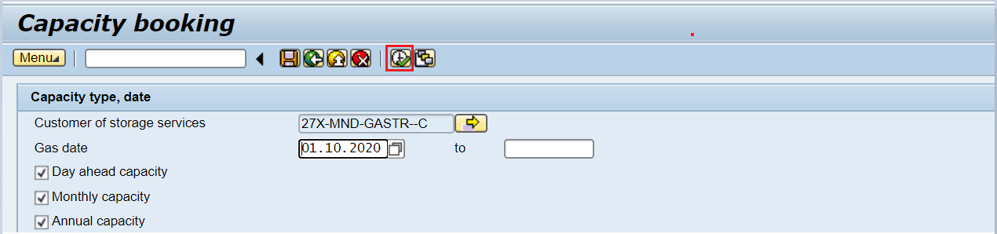
On the second screen you must click a button :
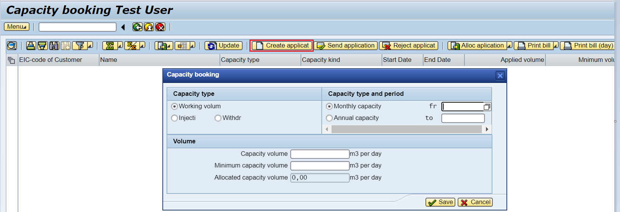

On the next screen, you need to fill in Capacity type:
- Working volume - storage capacity;
- Injection;
- Withdrawal.

You have also specify the Capacity period:
- Monthly capacity;
- Annual capacity.

Capacity volume, cubic meters per day:

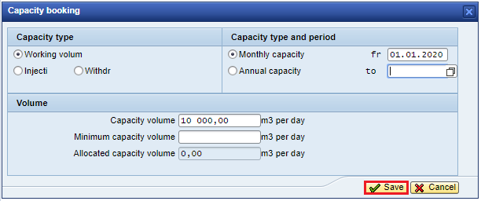
If the date of capacity booking is incorrect, the system will inform you with the following message (redo the error text):
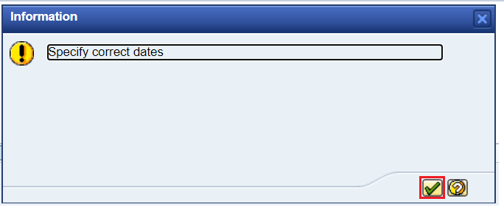

You will see the following after the dates actualizing:
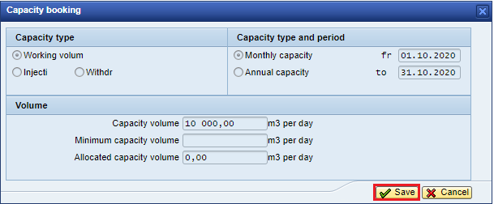

When saving, the system will inform you with the following message: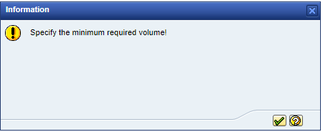
You will see the following after the filling minimum capacity volume: 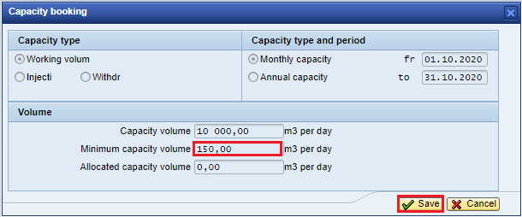
Informative message:

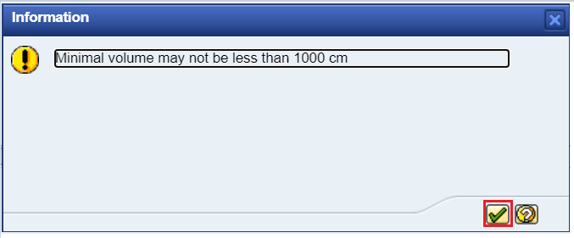

Fill the minimum capacity volume:
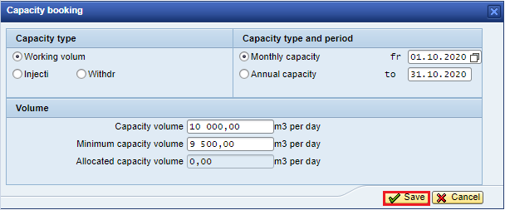

Similarly, applications for booking injection / withdrawal capacity are created.

ATTENTION!!! The application for booking injection / withdrawal capacity for the next month is created by the 10th day of the current month

To view the entered information on the initial screen, enter the gas day 01.10.2020:

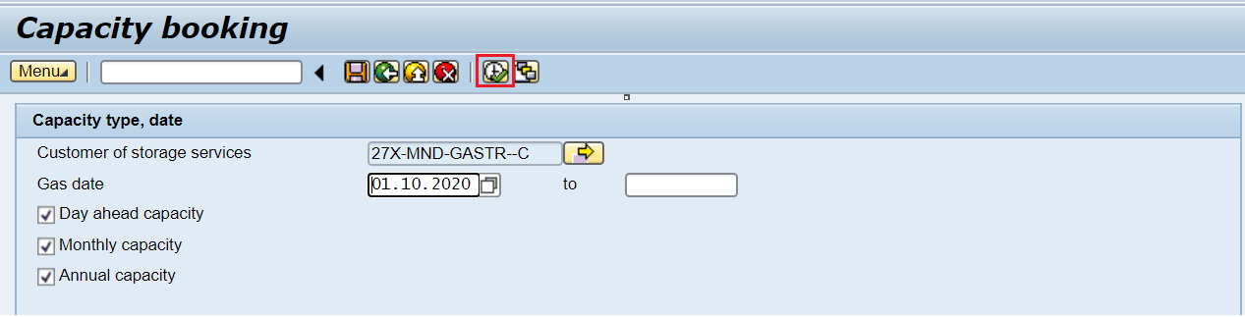

When performing a transaction, the system will display an application for booking the capacities of this customer:
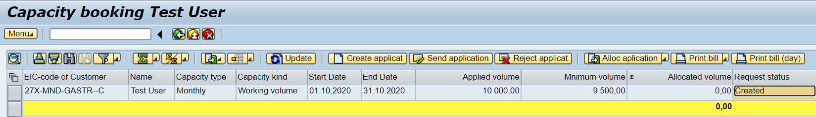

If the application for booking capacity is in the status of “Created”, the Customer of storage services has the opportunity to withdraw the request “Reject applicat”:

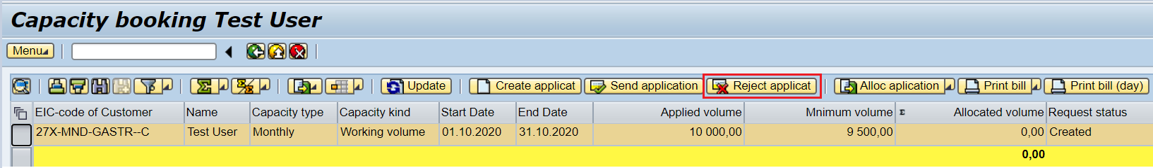
The application status will change to “Revoked”:
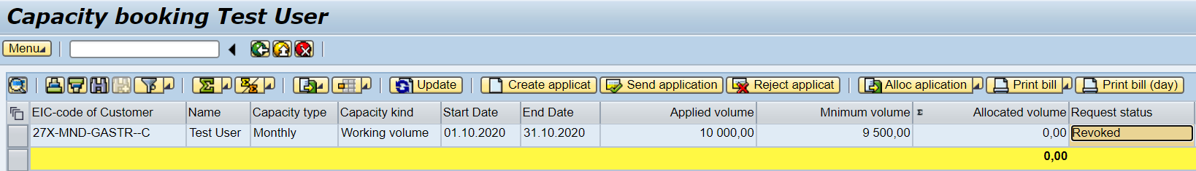
Attention! If the application is in the status "Revoked", it is impossible to send the application.
Create a new application:
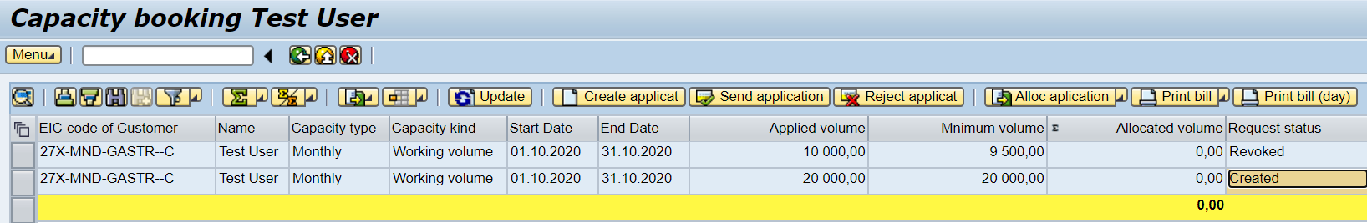
In the Created status, the Customer of storage services has the opportunity to download the application, to do this you need to click Alloc Application - Download application:
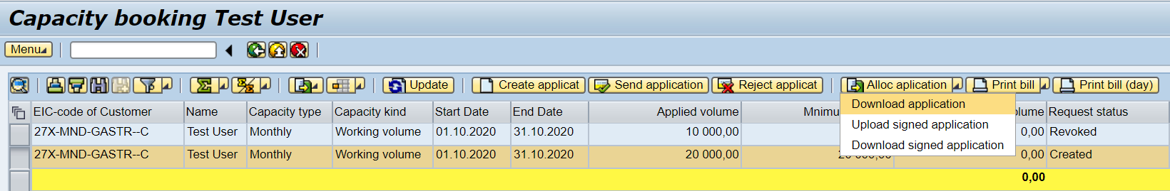
Save a copy to the native file system – Choose:
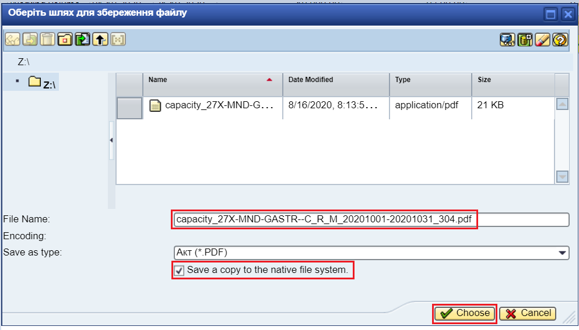
Further system informs with the following message:
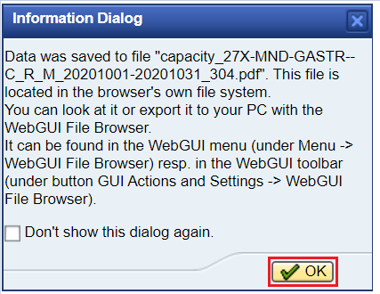
You have to click OK to save the file in its own file system:
The document has the following design:
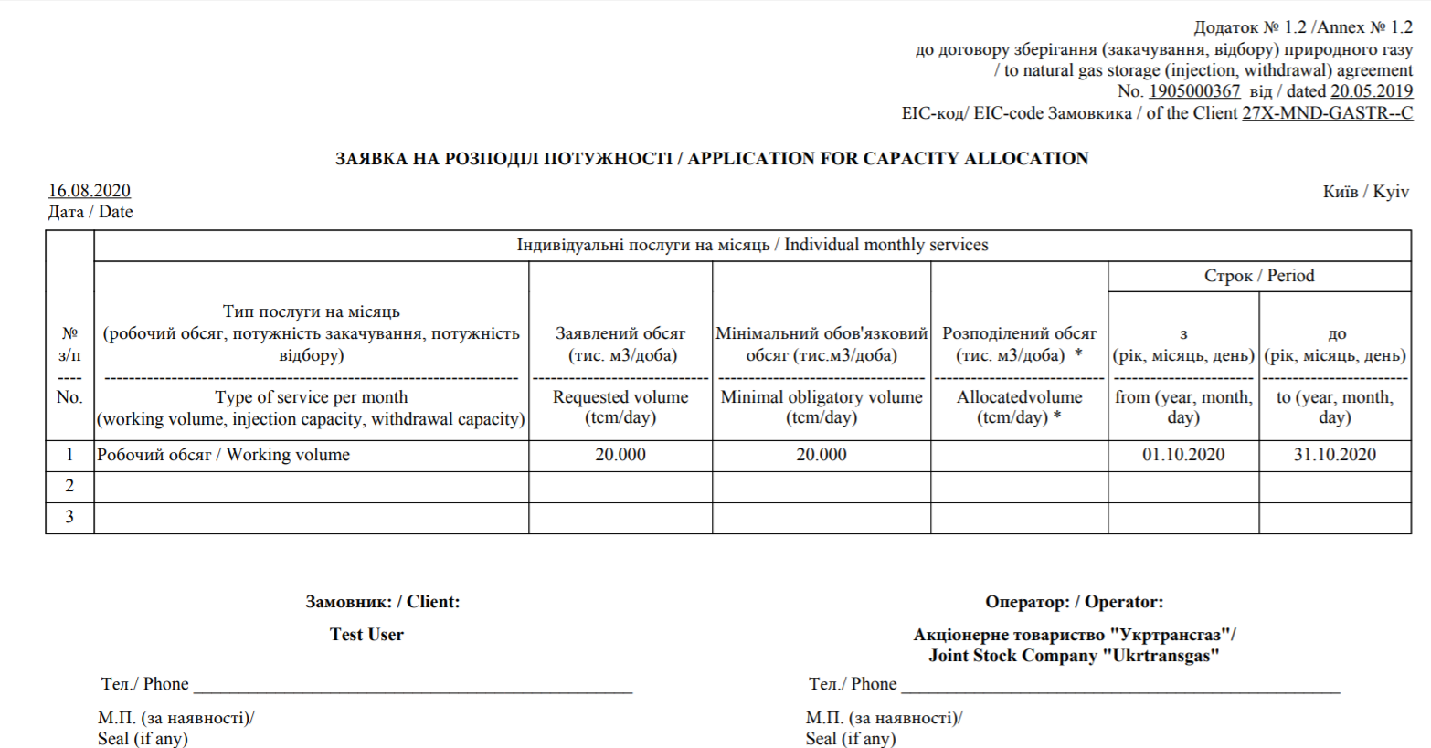

Further the Customer of storage services prints the Application for capacity allocation, signs and seals it, scans and uploads it to the information platform. You have to click Send application:
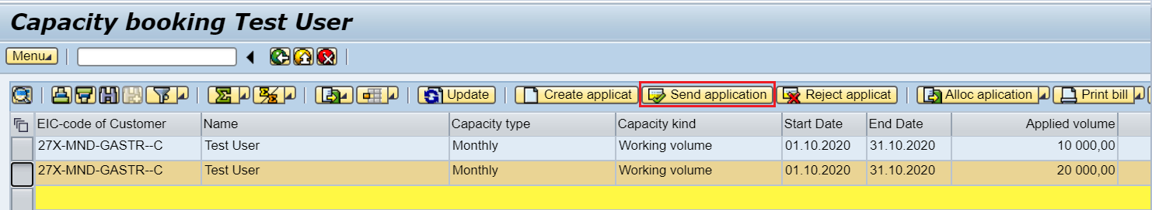
Then upload the signed document Application for capacity allocation:
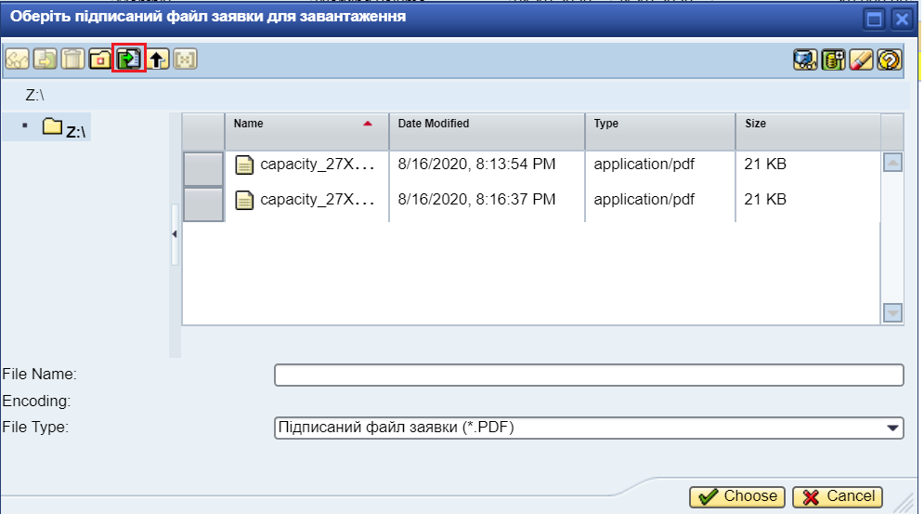

Choose the scanned file, click – Choose:
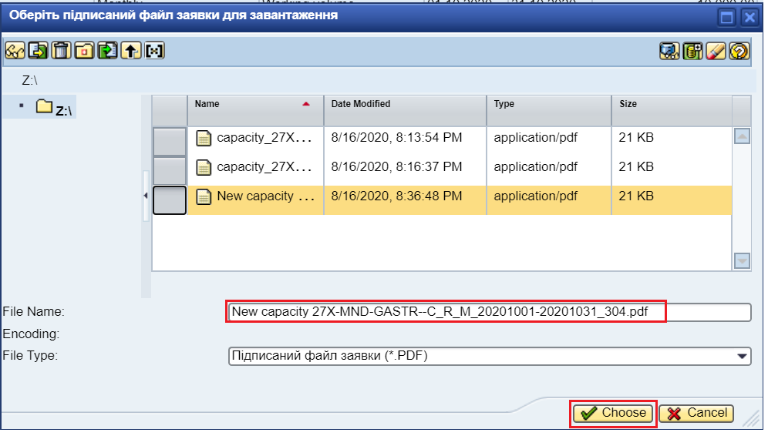
The application status is changed to Submitted: 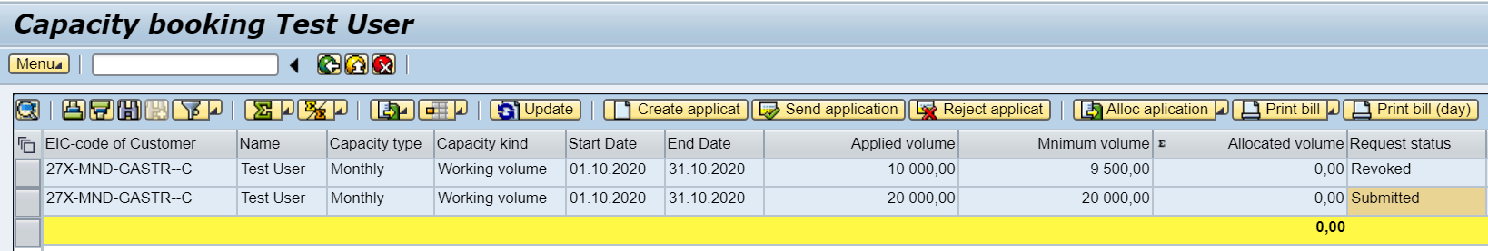
After changing the status of the application to Submited, the responsible employee of JSC "Ukrtransgaz" receives an e-mail and begins processing this application.

In the Submited status, the Customer of storage services has the opportunity to download the Invoice, to do this you need to click Print Bill - Download Signed Invoice:
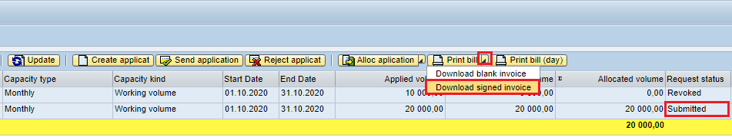
Save a copy to the native file system – Choose:
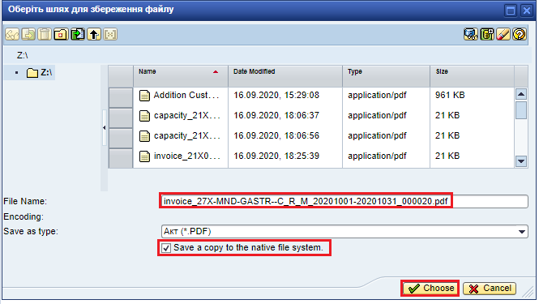
Further system informs with the following message:
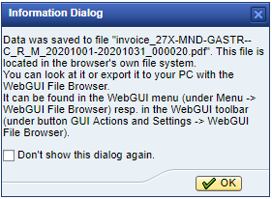
You have to click OK to save the file in its own file system:
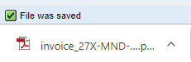

The document has the following design:
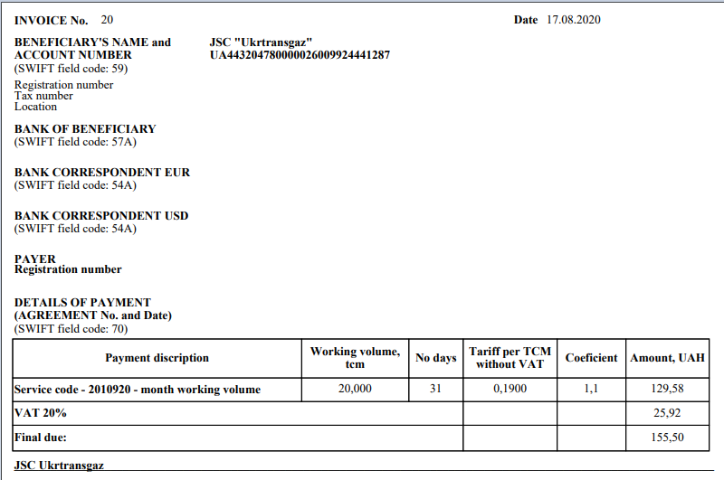
Customer of storage services has the opportunity to see if the invoice is loaded, for this you need to view the attribute – Signed invoice exist:
